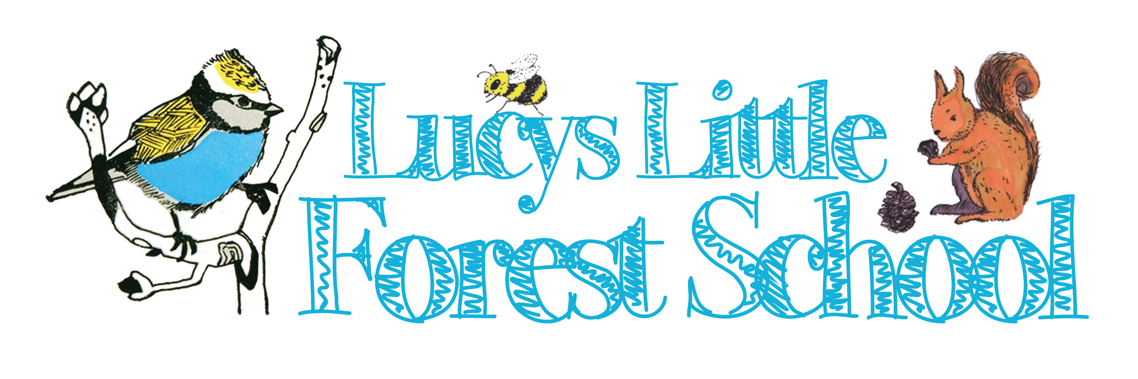
Woodland Art
Wilderness wood has a unique way of releasing a sense of adventure, stimulating imagination, unleashing creativity and restore a sense of wonder!
A lovely hands-on creative session for all ages, teachers, parents/carer’s to share together. Suitable for all Nursery and Reception, KS 1 and KS 2 and above.
Woodland art is about seeing what nature has to offer in a new light and appreciating the potential of diverse raw materials such as sticks, snow, leaves, depending on the season and the environment you are in. Learn how to work with them. It’s all about learning to use nature’s free renewable resources.
Some of these things may take time but children value there creations giving them a sense of pride. This not only brings children closer to nature but also connects them to ancient civilizations and technologies.

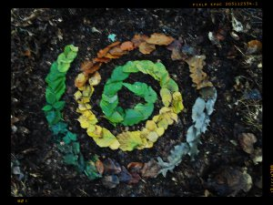Andy Goldsworthy

I enjoy the freedom of just using my hands and ‘found’ tools—a sharp stone, the
quill of a feather, thorns.
I take the opportunities each day offers: if it is snowing, I work with snow, at leaf fall
it will be with leaves; a blown-over tree becomes a source of twigs and
branches. I stop at a place or pick up a material because I feel that there is
something to be discovered. Here is where I can learn. Returning to one place
makes me more aware of change. I want to get under the surface. When I work
with a leaf, rock, stick, it is not just that material in itself, it is an opening into the
processes of life within and around it. When I leave it, these processes continue.
Quotes from Andy Goldsworthy, A Collaboration With Nature ( Abrams, 1990)

