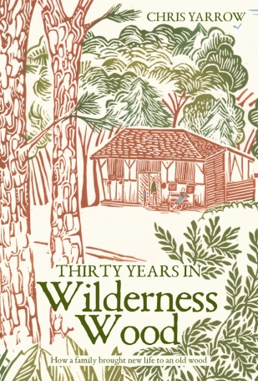
SPECIAL OFFER TO LUCY’S VISITORS - SAVE £3.00!

Pick up your signed copy of “Thirty Years in Wilderness Wood”
for only £13.95 when you visit (rrp £16.95)

Discover the inspiring story behind Wilderness Wood, and see the wood with new eyes.
Learn how Chris and Anne Yarrow and their two young daughters searched for and bought a wood where they could live out their dreams, and transformed an ordinary Sussex woodland into the much-loved place that you enjoy today. Read all the ups and downs, the fun and the narrow escapes. It's a handsomely-produced book with many illustrations and colour photos, and makes a fascinating read for yourself or a great present.

“Outstanding descriptive writing (with a) rare ability to create a text that takes the reader to the heart of the story” (Mark Pritchard, in Chartered Forester)
“It’s a long time since I’ve enjoyed a book so much. Chris and Anne Yarrow have crafted a masterpiece.” (Prof Julian Evans OBE, author)
“Chris Yarrow’s writing is masterful- as witty and full of sideways humor as it is informative.” (Dana Boussard, American artist, on publisher’s website)

Simply PRINT THIS PAGE AND TAKE IT TO THE WILDERNESS CAFÉ TO PICK UP YOUR BOOK(S) AND CLAIM YOUR SPECIAL PARTY/SCHOOL DISCOUNT PRICE OF £13.95
If you would like to have your book(s) before your visit, order a posted copy by emailing the author Chris Yarrow on yarrow@hmill.plus.com, and transfer £16.90* per book to C and A Yarrow account no 00039976, sort code 30-95-01, using your name as a reference; OR telephone Chris on 01825 831972;
OR write to Huggetts Furnace Mill, Stonehurst Lane, Mayfield, Sussex, TN20 6LL, enclosing a cheque for £16.90 per book payable to C & A Yarrow.
*Normal posted price £19.90.

