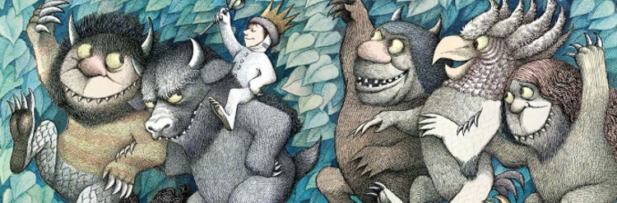
Where the Wild Things are Party Tea
Menu
- Crown Sandwiches with your choice of ham, cheese, marmite, or jam (please let us know whether you would like white or brown bread)
- Pepper and Cheese sailboats on a bed of crisps
- Cucumber tree
- Monster claws (chipolatas)
- Monster mouths - made from Apple and mini marshmallows
- Blueberry and starfish sea
- Wolf crispy cakes
- Jugs of monster squash

We are happy to cater for gluten free, vegetarian, dairy free and vegan diets, however please note on occasion there may be an extra charge for some ingredients.
Children’s party teas are available from Wednesday- Sunday, throughout the year however there are restrictions during weekends in November and December

Where are the party teas held?
During the summer months we hold the party teas in the tea garden or marquee (if it isn’t already reserved). During times of inclement weather and the rest of the year the party will be held in the cafe. However please note the cafe remains open to the public.

What do we provide?
We will provide the menu as quoted, a space to hold the party tea (as above), plastic plates, cups and of course napkins.

Do you need to bring anything?
You are welcome to bring your own birthday cake to have after the party tea. We are happy to supply plates or napkins for the cake, a knife and matches. Please remember to bring candles! You are welcome to bring balloons for the table and/or bunting (we do have some bunting already).

What about parents attending the party?
If you are expecting a number of accompanying parents we can provide a package of tea or coffee (americano’s with or without milk) with a tray of flapjacks and /or brownies for £3.50 per head; however we are equally happy for parents to buy their own coffees/teas. If the weather is inclement it can be a squeeze getting all the children and parents in the cafe, so it may be worth hiring an extra table (if parents are purchasing lunch from the cafe we will refund this cost).

Cost
The cost of the party tea is £7.00 per child (there is a supplement for numbers under 10). If you are looking to keep costs down is to pre-book our kiddies lunchbags. These are priced at £5.00 and include a sandwich, crisps, fruit, sweet option and squash.

What do I need to do now?
Complete the Party Extras Form online and we’ll be in contact to confirm your order.
A deposit of 50% of the total is payable at the time of booking the party (by cheque or bank transfer), the remaining balance is payable 48 hours prior to the party by bank transfer or cash on the day (unfortunately we are unable to take card payments for parties). Please make cheques payable to Wilderness Catering Ltd and sent to Wilderness Cafe, Wilderness Wood, Main Road, Hadlow Down, East Sussex. TN22 4HJ. Bank details are as follows: acc no 63182262 sort code 60-22-05, please use your booking name and date as a reference.
1 week before the party – please send us the confirmed number of children and advise which of the sandwich fillings you would like and whether you want white or wholemeal bread. Please let us know as soon as possible if you are aware of any food allergies or dietary requirements.
Please note that if we don't hear back from you regarding sandwich choices 48 hours before the party we will default to a selection of ham, cheese and jam sandwiches on white and brown bread.

Cancellation
Please note that numbers need to be confirmed 1 week prior to the event; it may be possible to add extras but we are unable to refund if children do not attend.
If you need to cancel, you can do so up to 1 week before and you can transfer your deposit to another date. Up to 48 hours, your 50% deposit will be retained. Less than 48 hours, 100% of the cost is payable.

