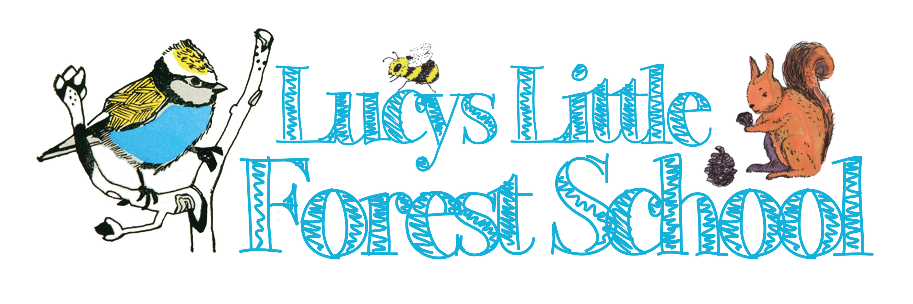

KS2
Coppicing and wood demonstration package

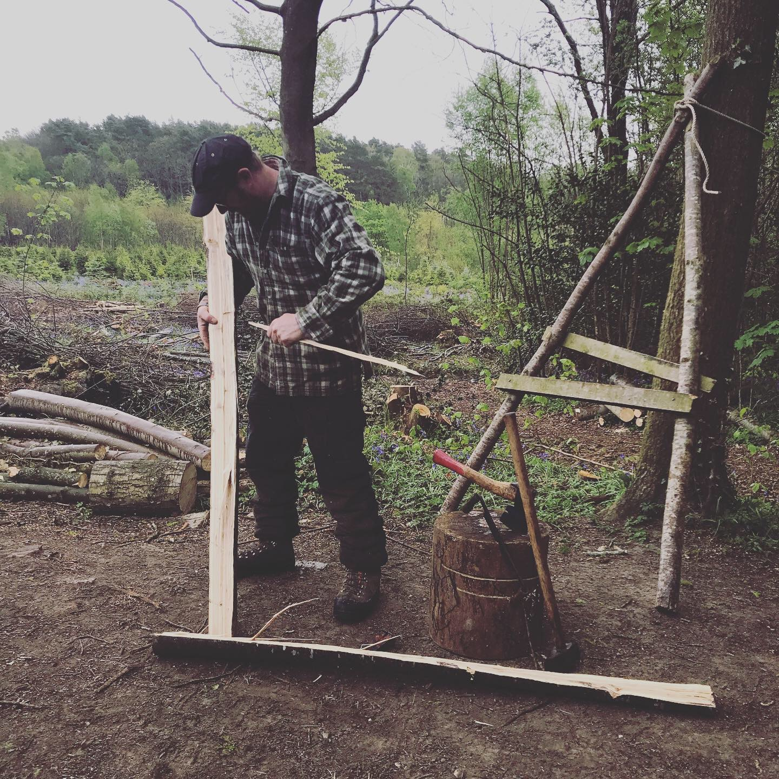

A hands-on wood demonstration experienced woodsman Andrew Coates. Coppicing is a form of Woodland Management dating back thousands of years. Here at Wilderness wood the team coppice sweet chestnut yearly in the winter months. Coppice Wood has many different uses ranging from firewood to woven fence panels, depending upon species and age, Visit a coppiced site at the wood, learn about this ancient technique and see what has been made from the wood from furniture, fence post even roof tiles. The children and adults are given the opportunity to get hands on with tools in a carefully supervised setting. Using a chestnut pole taken from the wood, the leader will help the children turn it into a useful item such as a shingle to a garden poles and other materials. We show the children how we make the best use of all the material, and what happens to the “waste”. The children handle tools and larger scale tool which have been used for centuries, under careful watch and help from the leader.
Topics catered for all age groups, primary through to sixth form. 1hour session to include the following;

• what is coppicing
• uses of wood
• what trees need to grow and threats to growth
• possible tree felling demonstrated
• making fence posts and roof shingles using hand tools
• sustainable woodland management
