Hornshurst wood - Rotherfield
Eridge Ln, Rotherfield, Crowborough nearest postcode TN63JU

Car park TQ555308
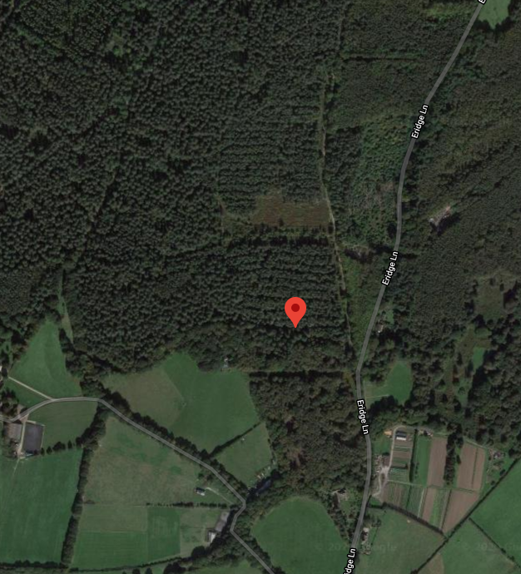
To Tunbridge Wells
Wells

To Rotherfield
Main forest track
Car park

